Wroughton Youth FC – Summer Tournament App

Software Architecture Document

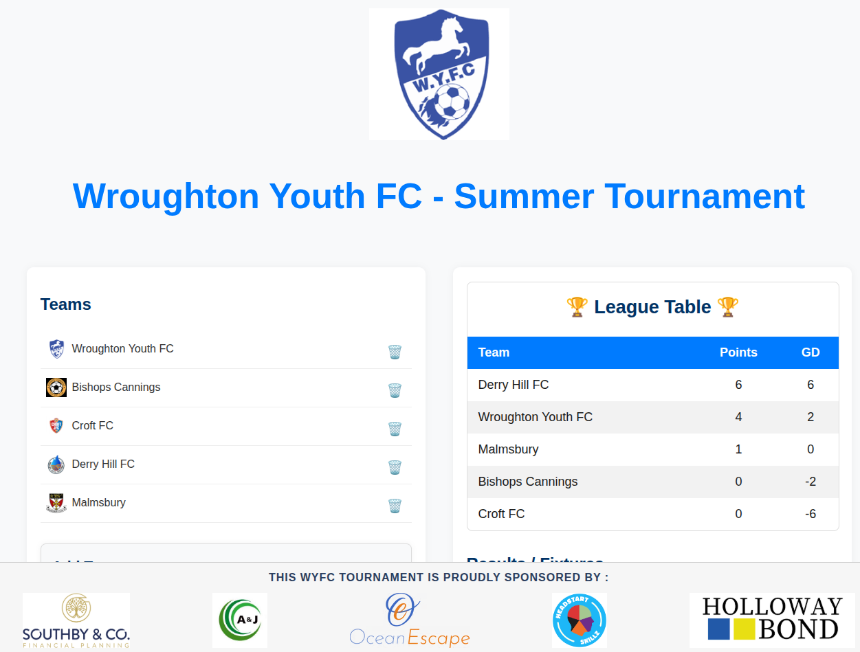

1. System Overview
The Wroughton Youth FC app is a small full-stack web application that allows users to:
✔ Manage teams (add/delete)
✔ Add/edit fixtures
✔ Submit match results
✔ View a dynamic league table
✔ Display sponsor logos in a sticky footer
The frontend is built with React (Vite).
The backend is built with Node.js (Express).
Data is persisted in PostgreSQL.
Communication between frontend and backend is via REST APIs.

2. Technology Stack
Layer | Technology
Frontend | React with Vite
Backend | Node.js + Express
Database | PostgreSQL
ORM/Driver | pg (node-postgres)
Deployment | Local, Docker (optional), cloud hosts
Icons & Styles | CSS, emojis or Font Awesome

3. Database Design
All tables live in a PostgreSQL database.

3.1 Teams Table
Field | Type | Notes
id | serial PRIMARY KEY | Unique team ID
team | varchar | Name of the team
logo | text | Path or filename to logo image

SQL
CREATE TABLE teams (
id SERIAL PRIMARY KEY,
team VARCHAR(255) UNIQUE NOT NULL,
logo TEXT
);

3.2 Matches Table
Field | Type | Notes
id | serial PRIMARY KEY | Unique match ID
home_team_id | integer | FK to teams.id
away_team_id | integer | FK to teams.id
home_score | integer | nullable
away_score | integer | nullable
played | boolean | default false
SQL
CREATE TABLE matches (
id SERIAL PRIMARY KEY,
home_team_id INTEGER REFERENCES teams(id) ON DELETE CASCADE,
away_team_id INTEGER REFERENCES teams(id) ON DELETE CASCADE,
home_score INTEGER,
away_score INTEGER,
played BOOLEAN DEFAULT FALSE
);

4. API Endpoints
All APIs are under the prefix:
/api/*

4.1 Teams API

GET /api/teams
Fetch the list of all teams.
Request
GET /api/teams
Response
[
{ "id": 1, "team": "Wroughton Youth FC", "logo": "wroughtonyouthfc.png" },
{ "id": 2, "team": "Bishops Cannings", "logo": "bishopscannings.png" }
]

POST /api/teams
Add a new team.
Request Body
{
"team": "New Team",
"logo": "newteam.png"
}
Response
{ "id": 3, "team": "New Team", "logo": "newteam.png" }

DELETE /api/teams/:id
Delete a team by ID.
Request
DELETE /api/teams/3
Response
{ "success": true }

4.2 Fixtures API

GET /api/matches
Fetch all fixtures.
Request
GET /api/matches
Response
[
{
"id": 1,
"home_team_id": 1,
"away_team_id": 2,
"home_team":"Wroughton Youth FC",
"away_team":"Bishops Cannings",
"home_score": 3,
"away_score":1,
"played": true
}
]
Tip: Frontend can join team names via backend or by including joins in SQL.

POST /api/matches
Add a new fixture.
Request Body
{
"home_team": "Wroughton Youth FC",
"away_team": "Bishops Cannings"
}
Response
{ "id": 5, ... }

POST /api/matches/:id/result
Submit or update the result of a fixture.
Request
POST /api/matches/5/result
Body
{
"home_score": 2,
"away_score": 1
}
Response
{ "success": true }

DELETE /api/matches/:id
Delete a fixture.
Request
DELETE /api/matches/5
Response
{ "success": true }

4.3 League API

GET /api/league
Returns the league table with statistics.
Request
GET /api/league
Response
[
{
"team":"Wroughton Youth FC",
"played":3,
"wins":2,
"draws":1,
"losses":0,
"goal_difference":5,
"points":7
}
]

5. Backend Implementation Notes
- Uses express.json() for JSON request bodies
- Wrap database calls with try/catch for error handling
- Responds with consistent JSON on success or failures
- CORS might be enabled depending on environment

6. Frontend Architecture

6.1 Pages / Components
App.jsx
├─ AddTeam.jsx
├─ TeamList.jsx
├─ LeagueTable.jsx
├─ Fixtures.jsx
├─ AddFixture.jsx
├─ SponsorFooter.jsx (optional)

6.2 Data Flow
App.jsx
├─ GET /api/teams → TeamList
├─ GET /api/matches → Fixtures
├─ GET /api/league → LeagueTable
├─ POST /api/teams → AddTeam
├─ POST /api/matches → AddFixture
├─ POST /api/matches/:id/result → Fixtures
└─ DELETE /api/... → Fixtures / TeamList

7. Deployment Considerations

7.1 Local
node app.js
npm run dev # frontend

7.2 Docker (Optional)
Use docker-compose.yml with services:
- postgres
- backend
- frontend
Mount volumes, env vars:
POSTGRES_USER, POSTGRES_PASSWORD, POSTGRES_DB

8. Security & Validation
✔ Validate input in POST/PUT routes
✔ Limit team names to acceptable length
✔ Sanitize inputs for database safety
✔ Add CORS config when deploying

9. Logging & Monitoring
- Add logging with morgan or winston
- Use structured logs for errors

10. Example API Contract Table (Swagger-style)
Path | Method | Description | Request Body | Response
/api/teams | GET | List teams | — | List of teams
/api/teams | POST | Add team | team, logo | Team object
/api/teams/:id | DELETE | Delete team | — | success
/api/matches | GET | List fixtures | — | Fixture list
/api/matches | POST | Add fixture | home_team, away_team | Fixture
/api/matches/:id/result | POST | Submit result | home_score, away_score | success
/api/matches/:id | DELETE | Delete fixture | — | success
/api/league | GET | Get league table | — | League table data

11. Screenshots

